Ideation Phase
Define the Problem Statements

Date | 31 January 2025
Team ID | 6ab3d8050fc666a751b367a2
Project Name | AI StudyBuddy
Maximum Marks | 2 Marks

Customer Problem Statement Template
Create a problem statement to understand students’ needs and challenges in managing their studies and daily schedules. The AI StudyBuddy with project focuses on helping students organize their study plans, receive AI-based study suggestions, and access real-time weather information.
A well-defined customer problem statement helps identify the difficulties students face in study planning and time management. It also helps the development team understand students’ requirements and create a user-friendly application that combines AI study assistance, reminders, and weather updates to support effective daily planning.
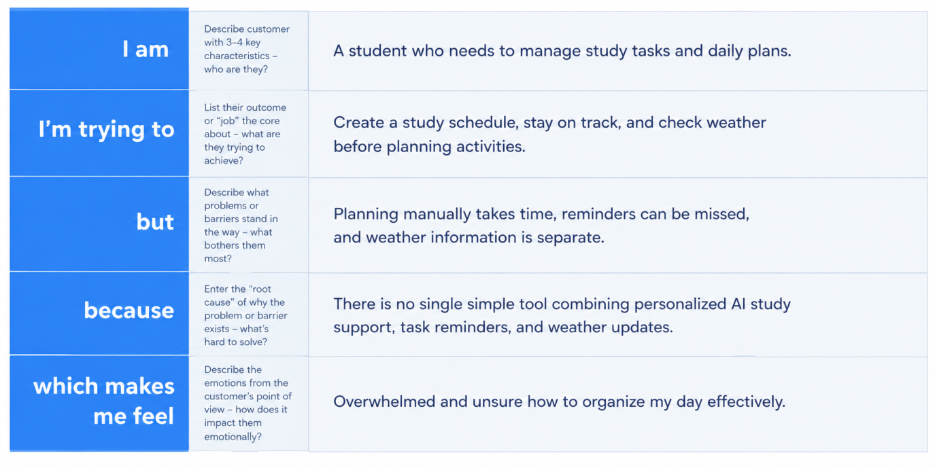

Example:
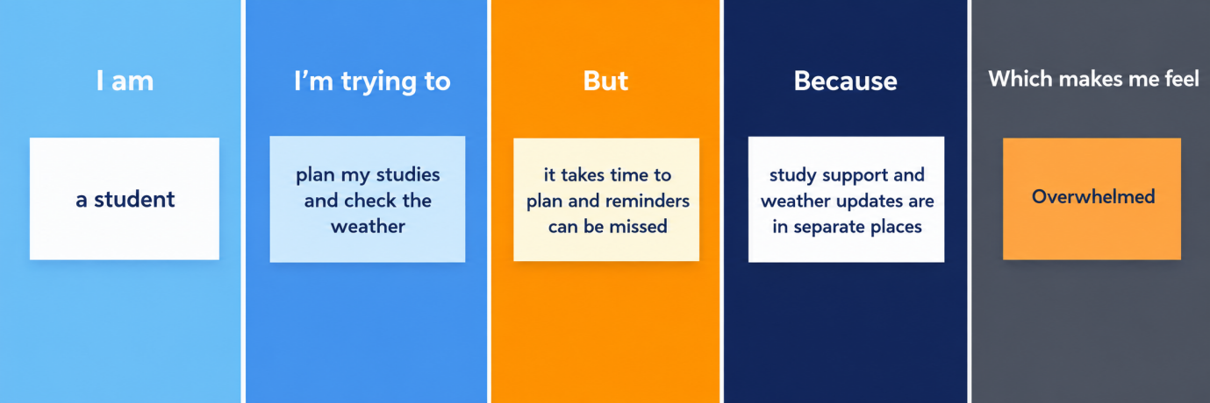

Problem Statement (PS) | I am (Customer) | I’m trying to | But | Because | Which makes me feel
PS-1 | A student who wants to manage study tasks and improve learning. | Create a study plan, get AI-based study assistance, and organize my daily study activities. | It is difficult to plan study schedules, manage time, and find suitable study support. | I do not have a single application that combines AI study assistance, study planning, and task management. | Confused and stressed about managing my studies effectively.
PS-2 | A student who wants to plan daily activities based on weather conditions | Check current weather information and organize my study and outdoor activities. | I need to check weather updates separately, which makes daily planning less convenient. | Weather information is not integrated with my study planning application. | Unprepared and uncertain when planning my daily schedule.

